Matei Vlad Cristian
321 CC
Laborator

1.
Algoritmul folosit pentru semnarea certificatului :

sha256WithRSAEncryption

Entitatea care a eliberat certificatul :

Issuer: C = US, O = Google Trust Services, CN = GTS CA 1O1

Intervalul de timp in care certificatul e valid :

Validity
Not Before: May 3 09:02:30 2021 GMT
Not After : Jul 26 09:02:29 2021 GMT

Cheia publica :

Subject Public Key Info:
Public Key Algorithm: id-ecPublicKey
Public-Key: (256 bit)
pub:
04:f7:f7:de:4d:af:d6:b4:ca:b5:49:1f:df:90:71:
cd:f6:cb:b7:fd:7a:d9:db:39:e4:93:68:2c:9d:55:
fb:1f:30:4e:75:e0:ef:58:29:4c:ac:66:3e:02:63:
f5:e2:3f:bc:2c:e1:55:3d:ae:d8:54:95:84:03:7c:
3f:7b:d5:2f:25
ASN1 OID: prime256v1
NIST CURVE: P-256

2.

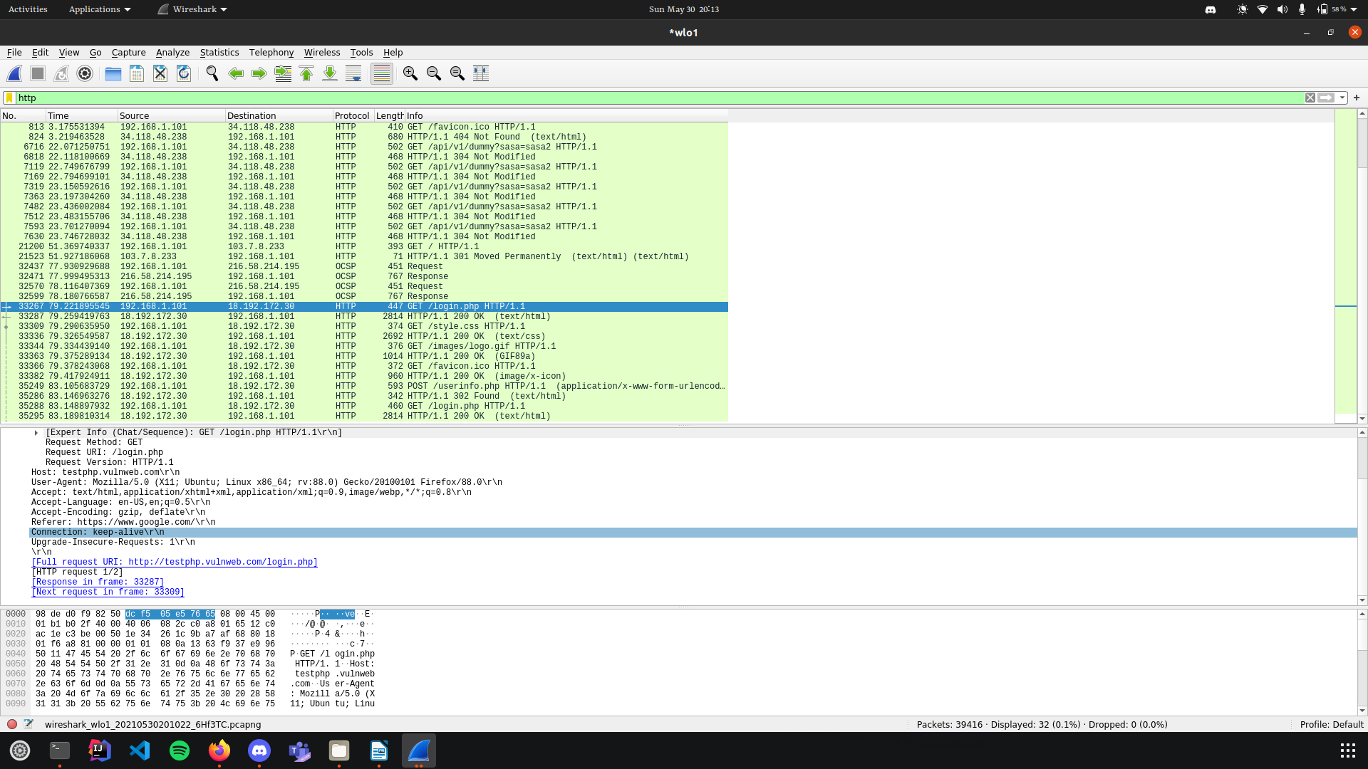
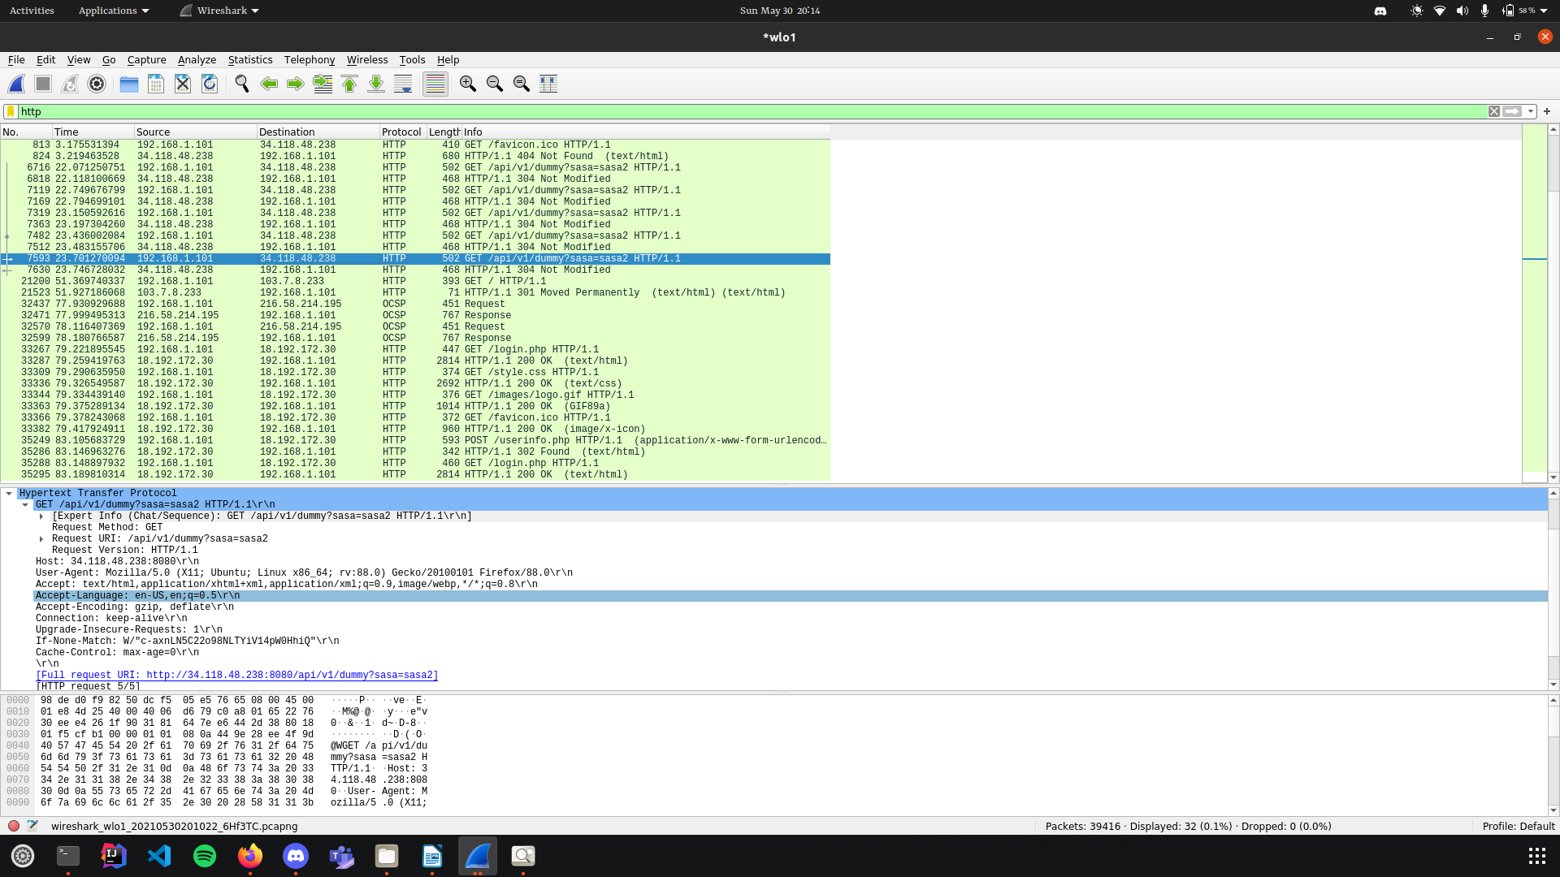

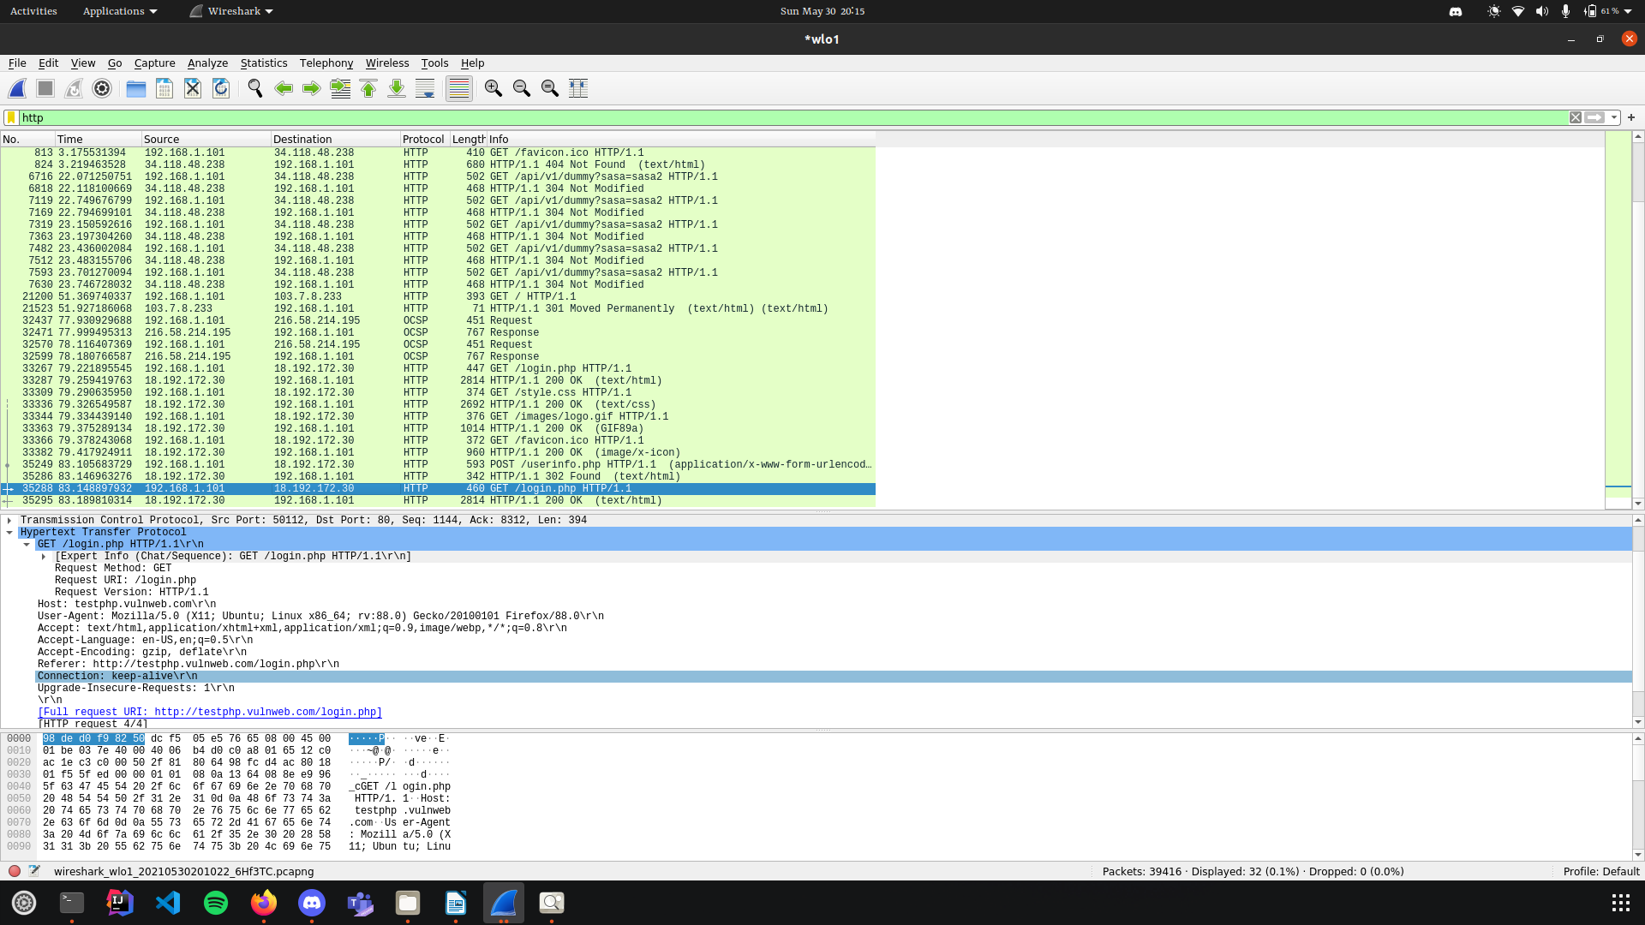
3.

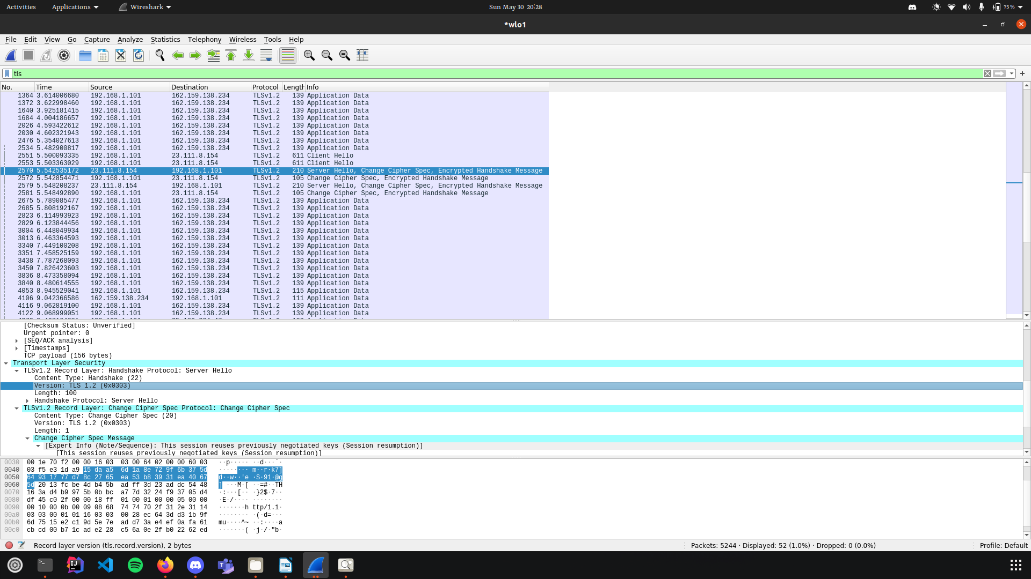

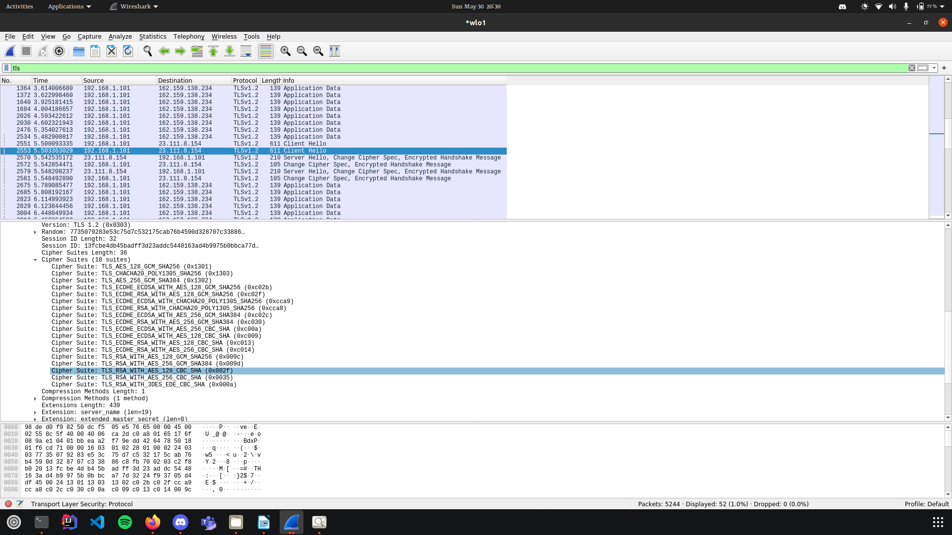

Cea aleasa de server:
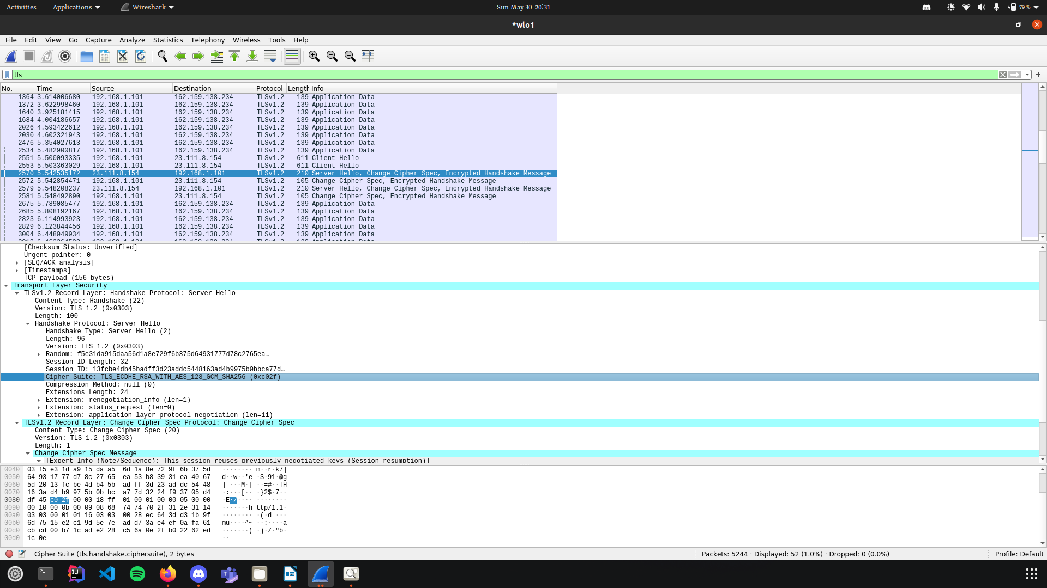

4.

